INTERNATIONAL STUDENT PROGRAM
INFORMATION
BOOKLET





Department of Education
CRICOS Provider Number: 00861K

Welcome to Huntingdale Primary School. We hope that your child has a wonderful educational experience at our school and that your family is connected to our wider school community. This information booklet is designed to help you understand our school, its policies and procedures.

School Location
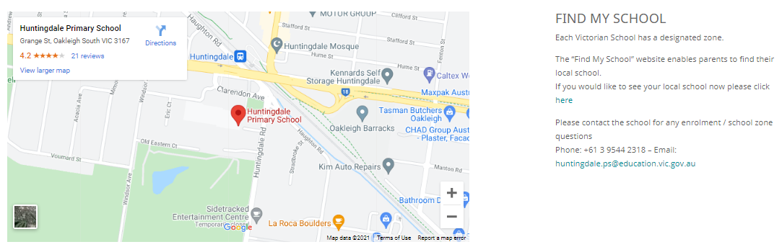

International Students Coordinator: Natalie Kerassitis
Email: natalie.kerassitis@education.vic.gov.au
Phone: +61 3 9544 2318
School Email: huntingdale.ps@education.vic.gov.au

CRICOS Provider Name: Department of Education and Training
CRICOS Provider Code: 00861K

Visa Requirements
Families must ensure they have the correct Visa and that it is kept up to date.

If the Visa lapses we will contact the International School’s Division.

If the Visa is not renewed the student’s place at the school will be revoked.

Health Cover
All International students must provide proof to the school that they have sufficient health cover

Induction/School Tour
Our Assistant Principal will conduct a school tour with international students and their families and complete an induction checklist.

Curriculum and course information
At Huntingdale Primary School, we teach the Victorian Curriculum for students from Foundation to Year 6. The curriculum is the common set of knowledge and skills required by students for life-long learning, social development and active and informed citizenship. For more information on the curriculum please see http://victoriancurriculum.vcaa.vic.edu.au/
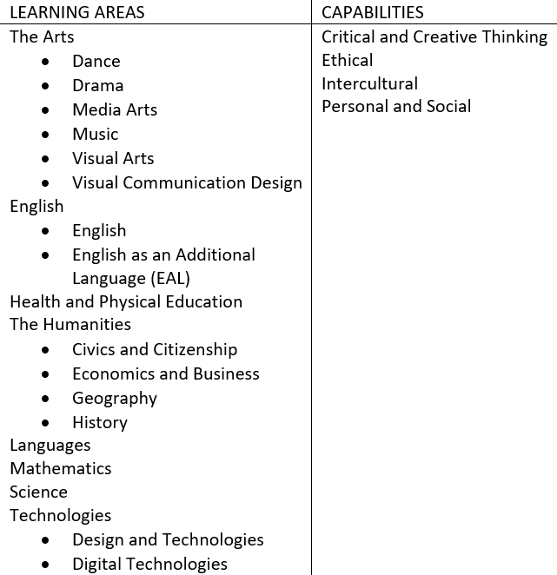

About our bilingual school
Huntingdale Primary School is a Japanese bilingual school, teaching students from Foundation to Year 6. The Victorian curriculum is taught to students through two languages- English and Japanese. The table below shows the hours in each subject.

 | Foundation to Year 2 |  | Year 3 to 6
Japanese 12.5 hours | Reader’s Workshop (2)  Writer’s Workshop (3)  Maths (5)  Drama (1)  Music (1)  Assembly (.5) | Japanese-  8 hours | Reader’s Workshop (2)  Writer’s Workshop (3)  Maths (5)  Music (1)  Drama (1)  Assembly/Wellbeing (.5)
English 12.5 hours | Reader’s Workshop (4)  Writer’s Workshop (5)  Reasoning and Problem Solving (1)  Art (1)  PE (1)  Assembly (.5) | English- 17 hours | Reader’s Workshop (3)  Writer’s Workshop (4)  Reasoning and Problem Solving (1)  Art (1)  Design Thinking (1)  Physical Education (2)  Assembly/Wellbeing (.5)

Minimum English and Japanese Language Levels
We highly recommend that students have basic level of English. They should be able to speak and follow simple English phrases (e.g. Yes please, stop! Can I go to the toilet? Please get your mathematics book, Can I get my lunch? When do we go home?)

Students are not required to have any Japanese language.

School Facilities and Map

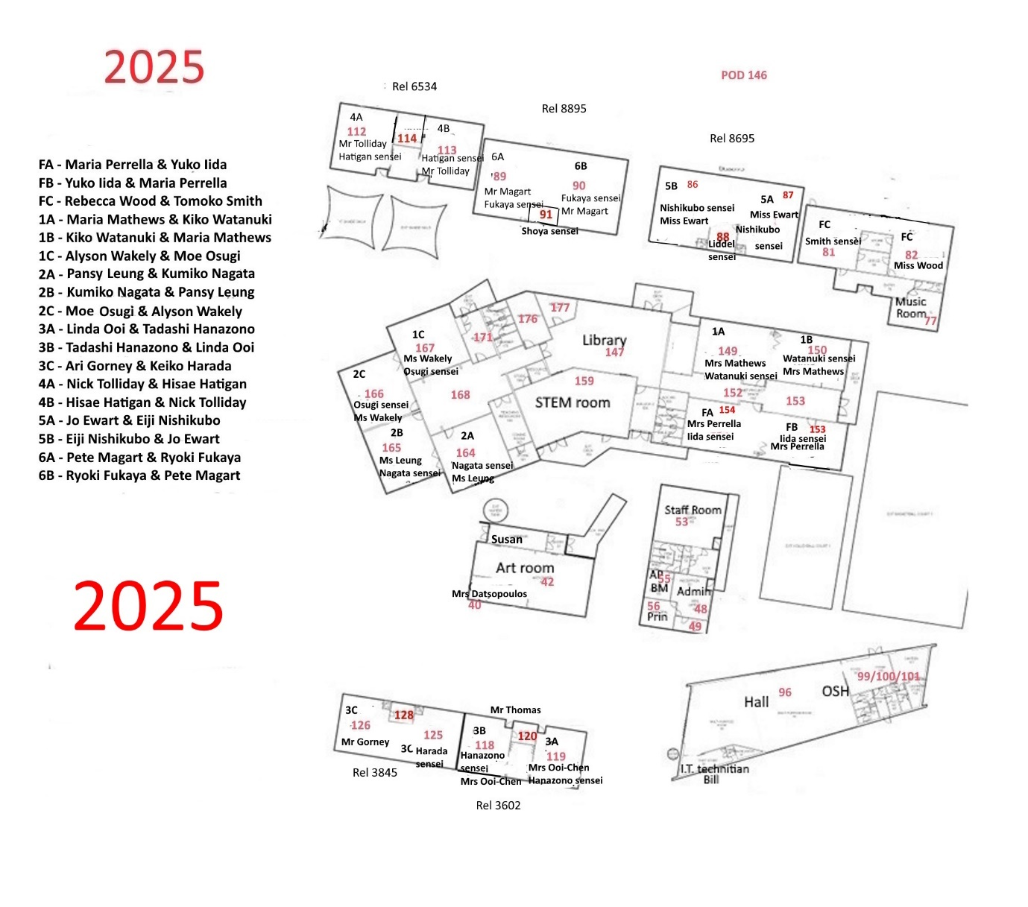

Before, After School and Vacation Care
Team Kids is our before and after school care provider and vacation care provider. See our website for more information (you will need to scroll down).

School Communications
The school uses the app Compass for school communications and the school newsletter.
Parents will need access to the Compass parent portal to access student reports.
The school office staff will help you connect to these.

Students use the app ‘See Saw’ to share their work. Your child’s teacher will help you set up this service.

School Terms
The school terms can be accessed by clicking here

Academic Performance, School Reports and Parent Teacher Interviews
The school has an Assessment and Reporting policy.

School reports are written in June and December. Parents download the report online from the Grade Xpert portal.

Parent teacher interviews are held in June. A ‘Share and Show’ Night is held each September.

The expectation is that students put effort into their academic performance whilst at Huntingdale and be supported by their family

If an international students’ academic performance is of concern the following will occur:

Stage 1: At Risk
- The Classroom teacher and Assistant Principal will meet with the student and their parents/guardians to discuss the academic performance. The child will be placed on an Individual Education Plan and this will be reviewed at a meeting each term. The child will be offered, where practical, student support services at the school.

Stage 2: Implement Intervention Strategy
- If unsatisfactory academic performance continues, the Assistant Principal will review the student support for the child at school. The Individual Education Plan will be reviewed.
- They will suggest that the family engage in support services to see if there are any learning difficulties affecting the child. e.g. educational assessment and also suggest they invest in support for the child e.g. tutor. The family will be expected to engage with these.

Stage 3: Final Unsatisfactory Academic Progress
- If the academic progress does not improve the school will contact the International Schools Division for advice.
- A meeting will be called between the school and parents/guardians.
- The school may recommend that the child repeats a year level so they can attain the academic skills needed.
Student Behaviour
The school has a Code of Contact Policy. Students are expected to display high standards of behaviour at all times and follow these norms:
- It takes great strength to be sensible.
- Be brave- participate to progress.
- Pursue your personal best no matter who you work with.
- Have reasons for the things you say and do.
- Treat others as you would like them to treat you.

At Huntingdale Primary School we use the 3R’s structure when dealing with conflict situations- Reflection, Repair and Restitution. Please see our policy for more detailed information.

If an international students’ behaviour is of concern the following will occur:

Stage 1: At Risk
- Classroom teacher and Assistant Principal will meet with the student and their parents/guardians to discuss the concerning behaviour and the expectations of the school. Regular communication will occur between the school and family to update progress in regards to behaviour.

Stage 2: Implement Intervention Strategy
- If unsatisfactory behaviour continues the Assistant Principal will suggest a range of support services for the student, e.g. counselling (through Better Places Australia, which can be accessed through the school at a low cost to families) and community based services. The family will be expected to engage with these.
- A behaviour plan will be put in place. This will be monitored.

Stage 3: Final Unsatisfactory Behaviour Meeting
- If the behaviour continues the school will contact the International Schools Division for advice.
- A meeting will be called between the school and parents/guardians
- The school will follow DET Guidelines relating to managing student behaviour
- If extreme behaviour occurs there may be circumstances the students’ place at the school will be revoked immediately.
School Attendance
The school’s Student Attendance Policy extends to international students. All planned absences must be approved by the Principal before the date.

If the child’s attendance is of concern the following will occur.

Stage 1: At risk- Attendance falls below 90%
- The classroom teacher, International School’s Coordinator and Assistant Principal will meet with the family to discuss the attendance concerns and the reasons behind the absences. An attendance plan may be put in place if needed.

Stage 2: Implement Intervention Strategy- Attendance falls below 85%
- The classroom teacher, International School’s Coordinator and Assistant Principal will put together an official attendance plan, including support strategies for the student and family.
- The International School’s Division will be contacted and given a copy of the plan.
Stage 3: Final Unsatisfactory Attendance- Attendance falls below 80%
- The school will contact the International Schools Division
- The students place at the school may be revoked.

Secondary Schooling Options
If your child is in Year 6, you may be looking for secondary schooling options in the near future.

All Fee-paying international students who want enrolment in a public school must make an application online at: www.study.vic.gov.au.

You can look up local government secondary schools in your area by using the website find my school findmyschool.vic.gov.au . This is the official and most up to date school zones map.

You can contact independent and catholic schools directly for enrolment details.

Interpreter Services
To use an interpreter over the phone call 131 450

School Based Student Support Services
The school has a range of support services for students, which can be found in our Student Support Policy. The Assistant Principal leads the Student Support Program.

Your child’s classroom teacher is also an excellent support. They will assign a ‘buddy’ to look after your child, particularly in the early stages of starting at Huntingdale.

Child Safe Standards
At Huntingdale Primary School, there is a culture of ‘no tolerance’ for child abuse.

The school strictly adheres to the Child Safe Standards.

For information on the standards and all the schools policies related to the standards please visit our website by clicking here

Emergencies
For fire brigade, police or ambulance dial 000 (or you can dial 112 from a mobile phone).

Critical Incident Plan
If an international student is involved in a critical event during school hours, the school’s Emergency Management Plan is enacted.

If a critical incident occurs to an international student out of school hours, we suggest the following:

Health Services
To find a doctor, chiropractor, dentist etc. in your area – as well as a comprehensive list of emergency numbers follow this link to ‘Find a Health Service’

Nurse on Call- 1800 022 222.

The closest hospital is Monash Medical Centre, 246 Clayton Rd – Clayton Vic 3168 –
Phone 03 9594 6666, webpage https://monashhealth.org/contact/monash-medical-centre/

Community Support Services

https://kidshelpline.com.au/
1800 551 800

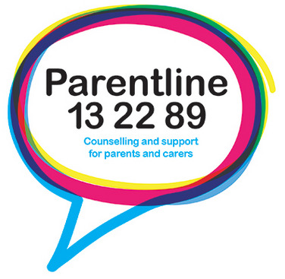
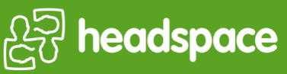
https://headspace.org.au/
(03) 9027 0100


https://www.beyondblue.org.au/
1300 22 4636

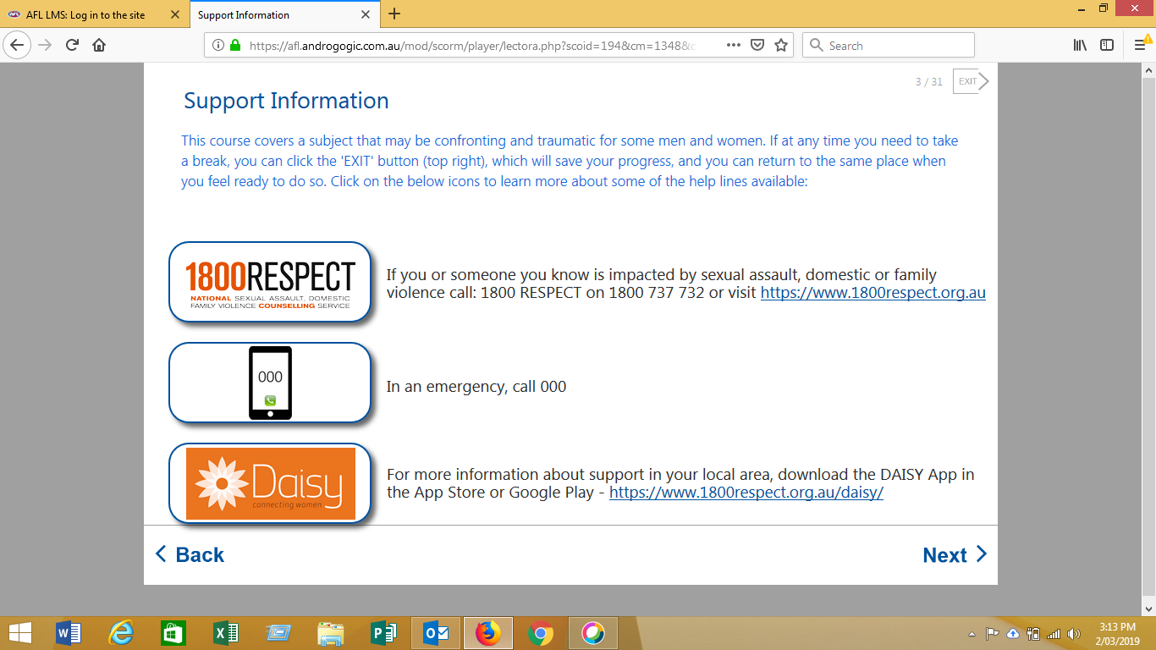
If you or someone you know is impacted by sexual assault, domestic or family violence call: 1800 RESPECT on 1800 737 732 or visit https://www.1800respect.org.au

In an emergency, call 000

For more information about support in your local area, download the DAISY App in the App Store or Google Play - https://www.1800respect.org.au/daisy/

CHILD FIRST
https://services.dhhs.vic.gov.au/referral-and-support-teams

ORANGE DOOR
https://www.vic.gov.au/familyviolence/the-orange-door.html

DHHS CHILD PROTECTION AREA
South Division 1300 655 795
East Division 1300 360 391
After hours, weekends, public holidays 13 12 78.

Legal Services
A range of legal services is available in the City of Monash, such as the
Springvale Monash Legal Service and the Monash Law Clinics - Clayton.

Legal Aid Victoria may also be of help

Local Area Information
The closest shopping centres are the Chadstone Shopping Centre, Oakleigh Central The Links Shopping Centre in South Oakleigh. And the Huntingdale shopping strip on Huntingdale Rd (within walking distance of school)

Information about Local library services can be found here.

Safety
Information on water safety in Australia can be found at Water Safety

Information on pedestrian safety can be found here

Transport
Huntingdale Train Station is near the school as well as a local bus service.

You need a MYKI card to access transport services. This can be purchased at newsagents and train stations

For information about public transports please go to https://www.ptv.vic.gov.au/
or ring 131 638.

For Travellers Aid ring 03 9619 2189.

Things to do around Melbourne
Visit the website https://www.onlymelbourne.com.au/things-to-do-in-melbourne.php for ideas and places to visit around Melbourne.

Complaints
If you need to lodge a complaint, please look up the school’s Complaints Resolution Policy. You will need to fill out a Complaint Form from the Study Vic website.

If the complaint cannot be resolved at the school level, the International School’s Division may be contacted.

